

**Project Proposal Report** **(Font Size 16, Bold)**

**Project Name (Font size 18, Bold)**

Group Name and ID (Font Size 14, Bold)

Client Name

Version (Font size 12)

Date

This proposal is submitted to the Information Technology department in partial fulfillment for the PPA module in the Diploma in Information Technology program.

# DECLARATION

We hereby declare that the project work entitled “Project Title”, submitted to the SLIIT City Uni (Pvt.) Ltd. a subsidiary of Sri Lanka Institute of Information Technology is a record of an original work done by us, under the guidance of our Supervisor “Name of the supervisor”. This project work is submitted in the partial fulfillment of the requirement for the award of the Diploma in Information Technology. The Results embodied in this report have not been submitted to any other University or Institution for the award of any degree or diploma. Information derived from the published or unpublished work of others has been acknowledged in the text and a list of references is given. (Normal Font Size 12, Headings must be bold)

**Project ID:**

**Group Members:**

|  |  |  |
| --- | --- | --- |
| **Student ID** | **Student Name** | **Signature** |
|  |  |  |
|  |  |  |
|  |  |  |
|  |  |  |
|  |  |  |
|  |  |  |

**Date of Submission:** ……………………………………..

|  |  |
| --- | --- |
| Supervisor | Client |
| Name : | Name : |
| Signature : | Signature : |

Table of Contents

DECLARATION i

LIST OF TABLES iv

LIST OF FIGURES iv

1 INTRODUCTION 1

1.1 BACKGROUND OF THE CLIENT/ PROJECT 1

1.2 PROBLEM STATEMENT 1

1.3 NEEDS STATEMENT 1

1.4 SOLUTION AND OBJECTIVES 1

2 PROPOSED TECHNICAL APPROACH 2

2.1 DEVELOPMENT METHODOLOGY 2

2.2 REQUIREMENT GATHERING 2

2.3 ARCHITECTURE DIAGRAM 3

2.3.1 AS IS SYSTEM 3

2.3.2 TO BE SYSTEM 3

2.4 FUNCTIONAL REQUIREMENTS 4

2.5 NON-FUNCTIONAL REQUIREMENTS 4

2.6 IMPLEMENTATION AND DEVELOPMENT REQUIREMENTS. 4

2.7 RUNNING ENVIRONMENT REQUIREMENTS 4

2.8 QUALITY ASSURANCE PLAN 4

3 EXPECTED PROJECT RESULTS 5

3.1 DELIVERABLES 5

3.2 MEASURES OF SUCCESS 5

4 BUDGET 6

5 ROLES AND RESPONSIBILITIES 7

6 SCHEDULE 8

7 REFERENCES 9

8 APPENDICES 10

# LIST OF TABLES

Table 3.2.1: Roles and responsibilities of the project. 7

# LIST OF FIGURES

Figure 2.1.1: Waterfall development methodology [1] 2

Figure 2.3.1: AS IS System 3

Figure 2.3.2: TO - BE System 3

# INTRODUCTION

Explain what you are going to describe in this chapter

## BACKGROUND OF THE CLIENT/ PROJECT

[Description about your client and their business operations. If the project is an own idea description about the field of the study/project]

## PROBLEM STATEMENT

Description about their as – is – system and drawbacks of it. Explain the elements, Affects, Results of activities and so on. Describe the background information about the project, including the description of the current solutions and the problems you have discovered.

## NEEDS STATEMENT

State short-comings apparent in current organization or system to be addressed by the project.

## SOLUTION AND OBJECTIVES

Identify changes desired to be seen upon completion of effort. List down main objectives of the project where you address the problems of the current system or current situation.

# PROPOSED TECHNICAL APPROACH

Under this chapter, define clearly a well thought-out and solid technical plan for applying information technology to the proposed project. This section should include a description of the methodology to be used to complete the project, a specific plan for gathering requirements, an architecture design, best practice for implementation, and quality assurance.

## DEVELOPMENT METHODOLOGY

Explain your selected development methodology with proper reasons. You can use references and figures. Figures must be referred to a figure table. I have given a sample Figure and Reference. All the referencing must follow IEEE conventions.

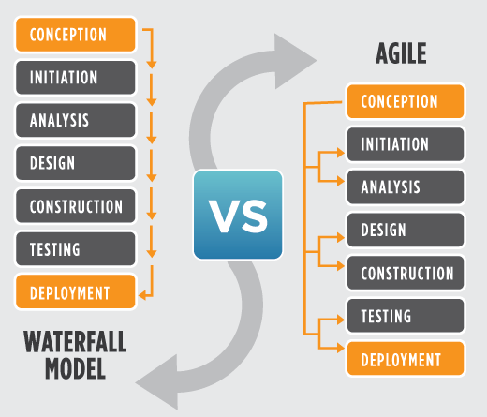

Figure .: Waterfall development methodology [1]

## REQUIREMENT GATHERING

Explain how you have gathered details for the proposal. (Interviews, Questionnaire or any other methods. Provide images and other things as appendices)

## ARCHITECTURE DIAGRAM

Explain the Architecture diagram and under this topic present the as is system and To be system.

### AS IS SYSTEM

Give a Figure of As-Is system.

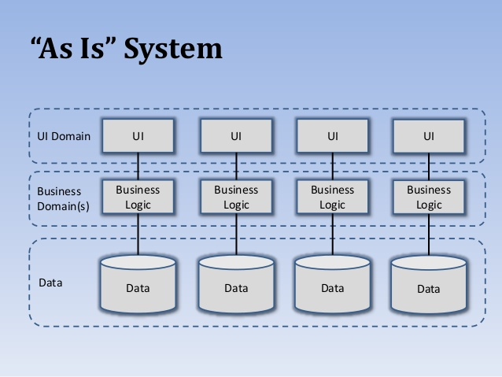

Figure .: AS IS System

### TO BE SYSTEM

Described figure of the to be system

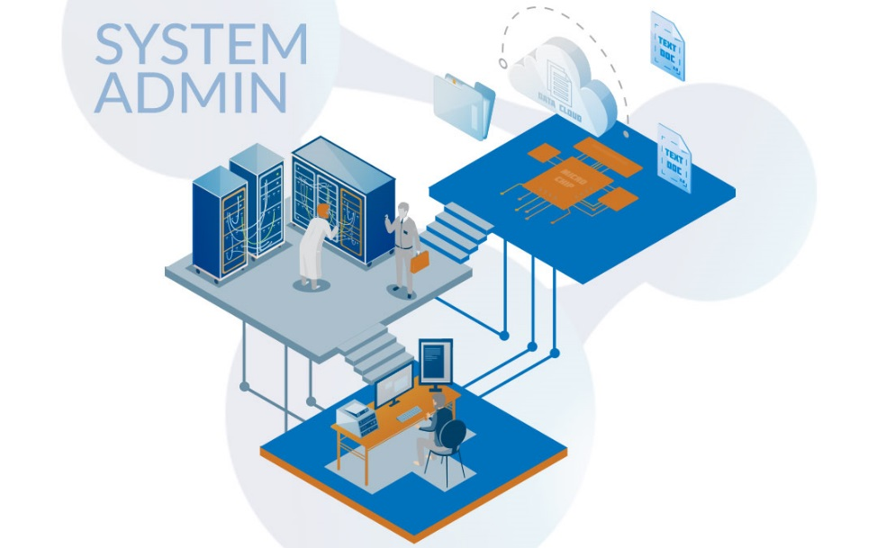

Figure .: TO - BE System

## **FUNCTIONAL REQUIREMENTS**

Present the requirements as understood at this time through contacts with the stakeholder. Include a high-level diagram such as a use case system diagram (Basic Diagram only) or block diagram to capture the situation being addressed.

## NON-FUNCTIONAL REQUIREMENTS

Present the non-functional requirements of the system.

## IMPLEMENTATION AND DEVELOPMENT REQUIREMENTS.

Describe your methodology for implementation which includes details about platform and technologies to be used in the project.

## RUNNING ENVIRONMENT REQUIREMENTS

Describe the requirements of the environment to run your application.

## QUALITY ASSURANCE PLAN

Describe the potential risks related to the software quality. Provide the project management plan to enable quality. Describe the salient, planned testing considerations.

# **EXPECTED PROJECT RESULTS**

List deliverables expected to be produced for the project, and for the stakeholder.

## DELIVERABLES

List of the main deliverables.

## **MEASURES OF SUCCESS**

Describe an assessment plan to identify the degree of achievement obtained by the operation of the project. List a measure, its relevancy to the organization, its current value, and its projected improved value. A measure should also correspond to the stated objectives of the project.

# BUDGET

Estimate budget for the project under this section. Clearly mention your assumptions and calculations.

# ROLES AND RESPONSIBILITIES

Roles and responsibilities of project members should be clearly stated in the beginning of the project.

**The following table can be used as a template:

Table .: Roles and responsibilities of the project.

|  |  |  |
| --- | --- | --- |
| Role | Responsibility | Participant(s) |
| Project Sponsor |  |  |
| Project Leader |  |  |
| Analysis |  |  |
| Design |  |  |
| Implementation |  |  |
| Testing |  |  |

# SCHEDULE

Include principal tasks, their duration, and their sequence. Wherever possible, the methods and task to be performed should be outlined in logical sequence and explained in detail. Include a proper GANTT Chart here.

# REFERENCES

|  |  |
| --- | --- |
| [1] | M. Lotz, "Waterfall vs. Agile," Segue Technologies Inc, 05 July 2018. [Online]. Available: https://www.seguetech.com/waterfall-vs-agile-methodology/. [Accessed 17 July 2019]. |

# APPENDICES

**STYLE CONVENTIONS (Only for reference remove from your final report)**

**FORMAT**

The proposal should be typed. All text, Figures and Tables should appear on only one side of each sheet of paper. All pages other than the cover sheet should have page numbers that begin with “1” on the first page after the content page and should continue through the last page of the reference page, but not the appendices.

The right-hand, Upper and Lower margin should be 1”. The left-hand margin must be 1.5” on each page of the document because of the binding. The margin instructions should be followed in the appendices as well.

The font size in the text should be in 12, in subsections 12 and in the main headings 16. The main headings are to be written in capitals and placed at the beginning of a new page. Level 2 Heading should be 14 and all capitals. All level 1 and 2 headings are to be in bold letters. Level 3 headings must be 12 all capitals. Leave two empty lines under the main heading, two empty lines above the subsection and one empty line under it. The headings should not have more than three numbers. A line spacing of 1.5 should be used in the text, 1 on the title page and in the abstract. The font to be used is Times New Roman. The page number is placed in the lower right corner.

The text should not be indented and both margins on the page should be justified. When a paragraph continues the next page, at least two lines of the paragraph should be left on the upper or lower end of the page. The paragraphs are separated from each other and from the headings with one empty line. A new chapter is started on a new page. One empty line is needed to separate two paragraphs.

PARAGRAPH TEXT

The text of the report should be written in complete sentences. The style should be formal. Formal style means to avoid abbreviations that are common in spoken English.

FIGURES AND TABLES

All Figures and Tables should have a number and a caption. Tables should have the caption before the table and for figures the caption should be placed at the bottom of the image. If a figure or table is extracted from a source; the source should be cited in the references.